UNIT-1
- Install Matplotlib and display a simple line graph.
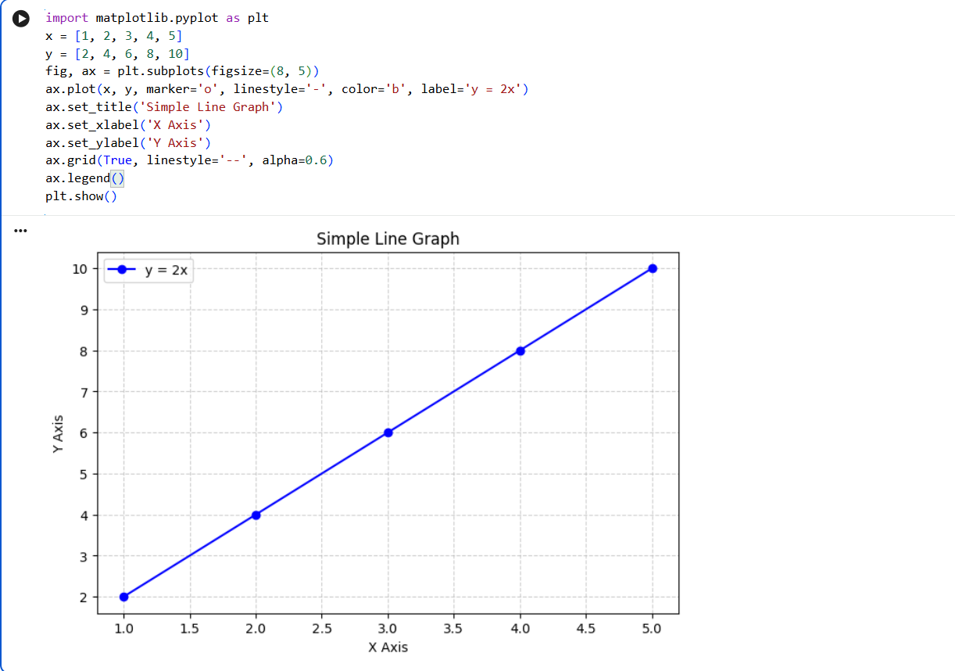

- Install Scikit-learn and print its version.
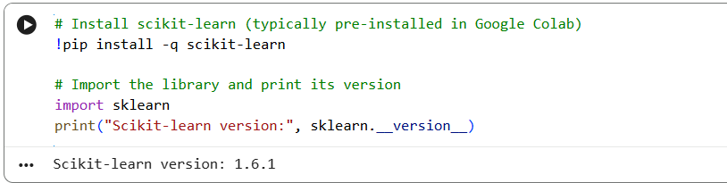

- Create a NumPy array containing the first 20 natural numbers.
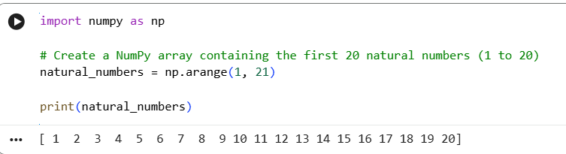
- Create a Pandas DataFrame with student names and grades.
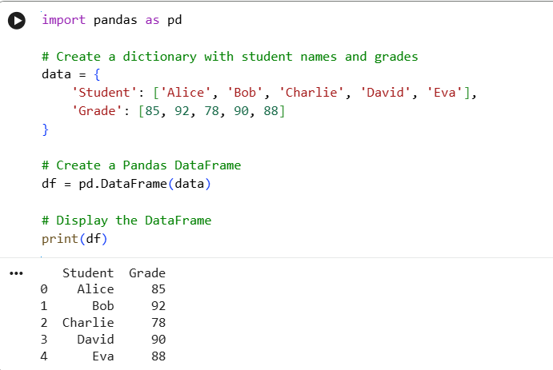

5. Verify the installed versions of all AI libraries on your system. 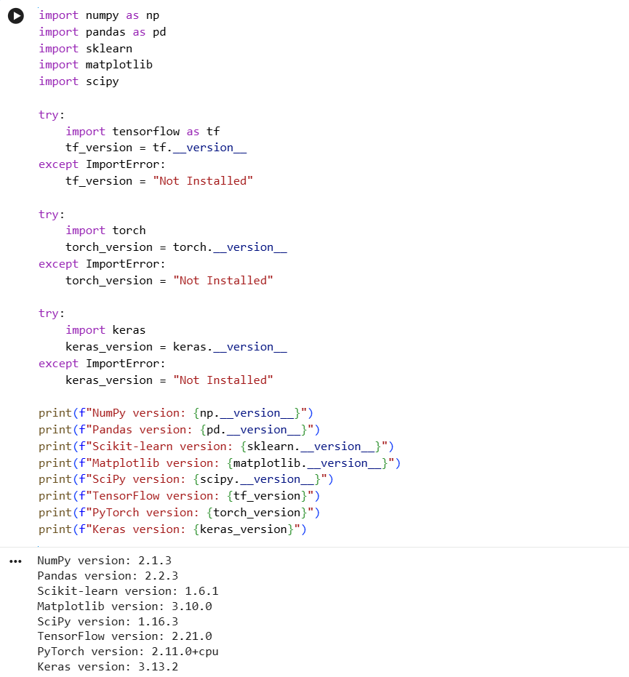

6.Create tensors using PyTorch and perform basic mathematical operations.

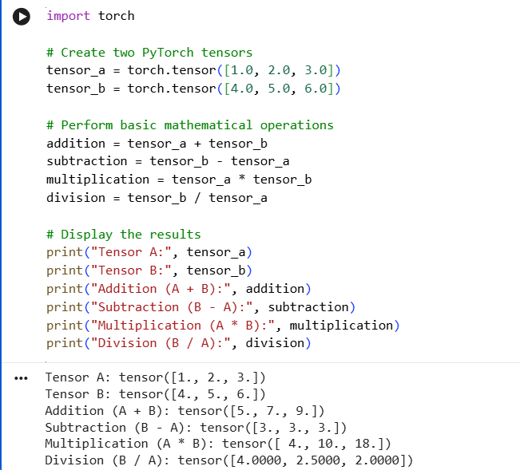

7. Load a Pre-trained Transformer Model using Hugging Face and perform sentiment analysis.
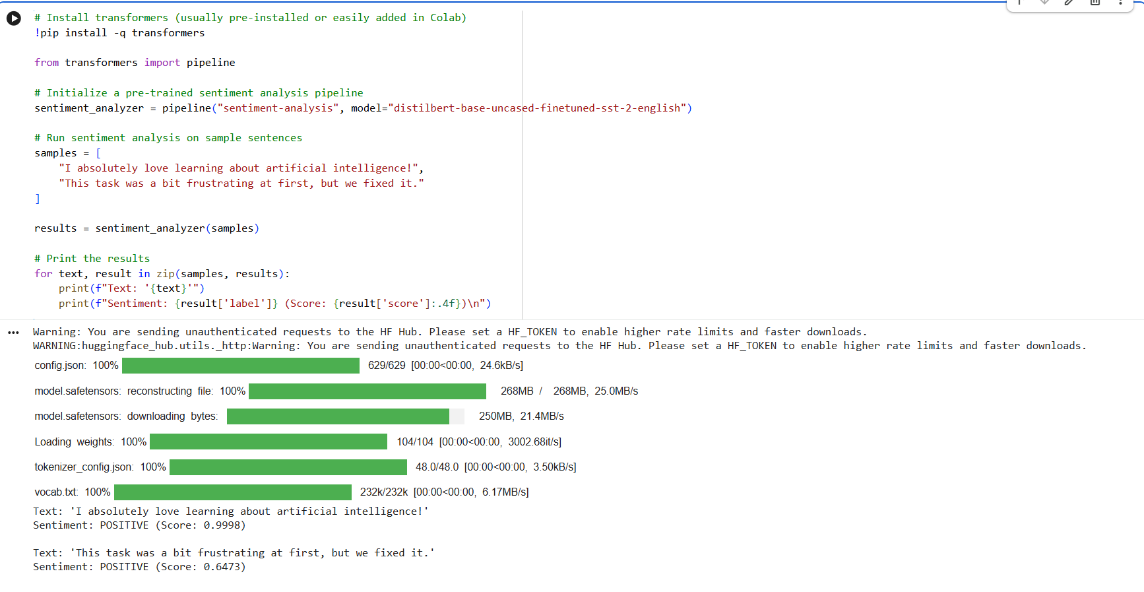
8. Tokenization using BERT Tokenizer
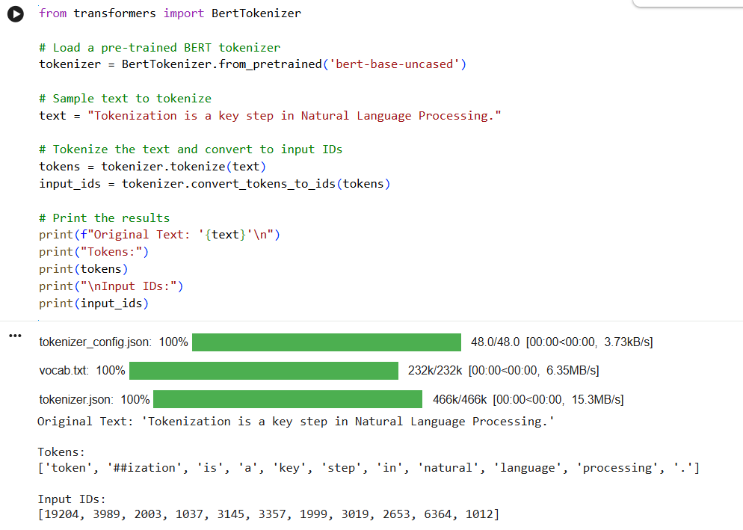

9. Generate text using a pre-trained GPT-2 model.
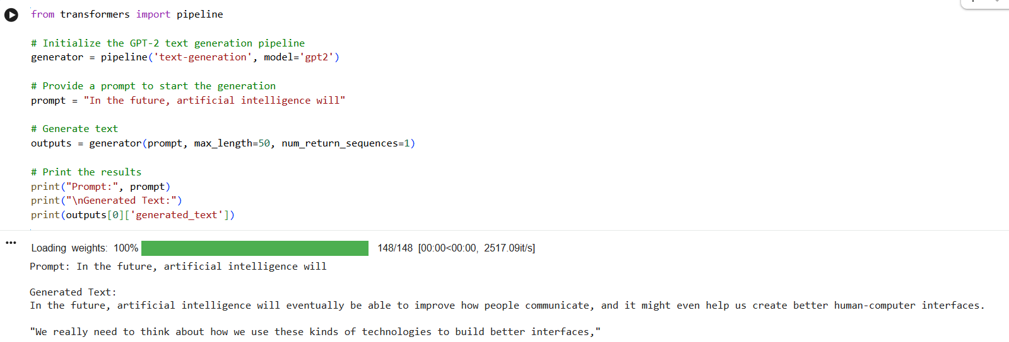

10. Load a pre-trained transformer model using the Hugging Face pipeline() API and perform sentiment analysis.
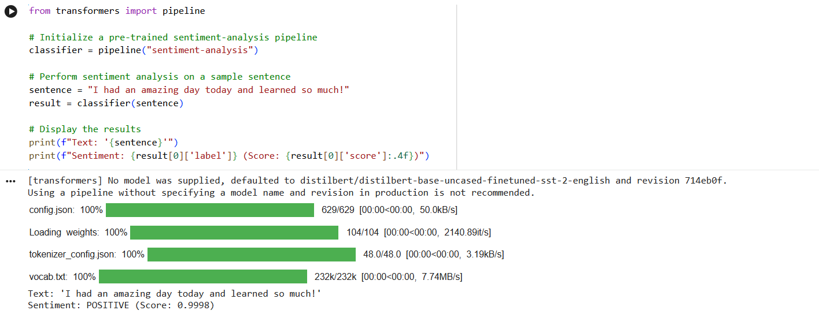

11. Load the BERT tokenizer and tokenize a sentence.
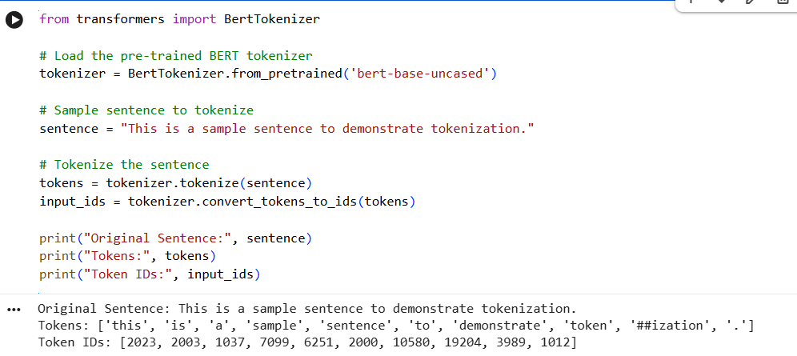

12. Load a pre-trained BERT model and generate contextual embeddings.
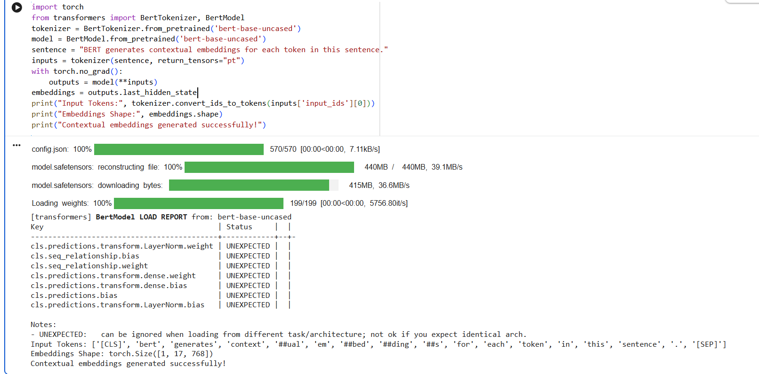

13. Generate text using a pre-trained GPT-2 model.
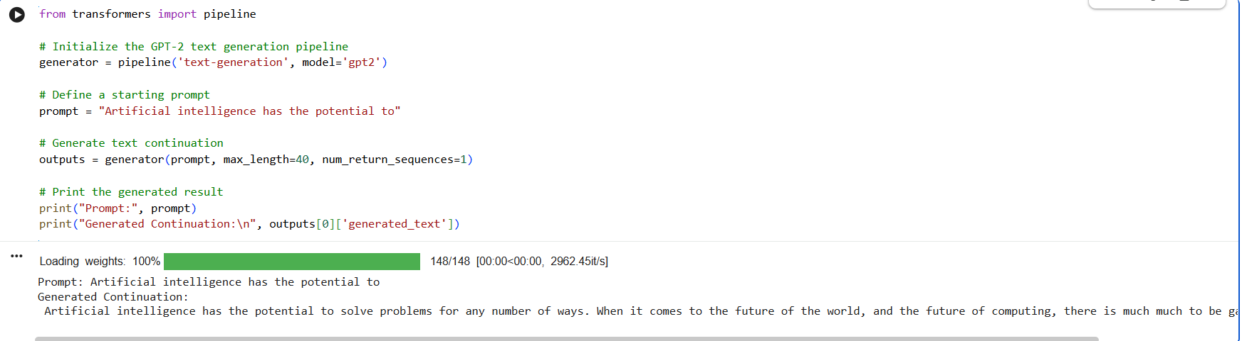

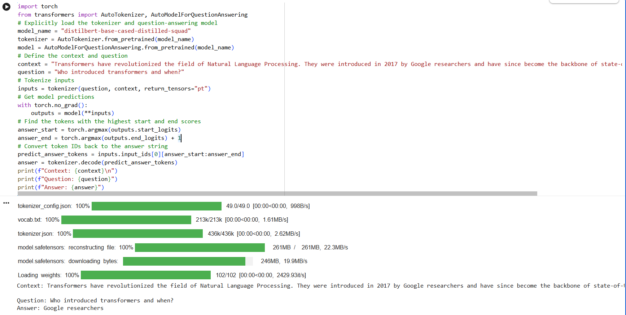
14. Question Answering using a Pre-trained Transformer

15. Tokenize a sentence using the BERT tokenizer and display the generated tokens and token IDs.
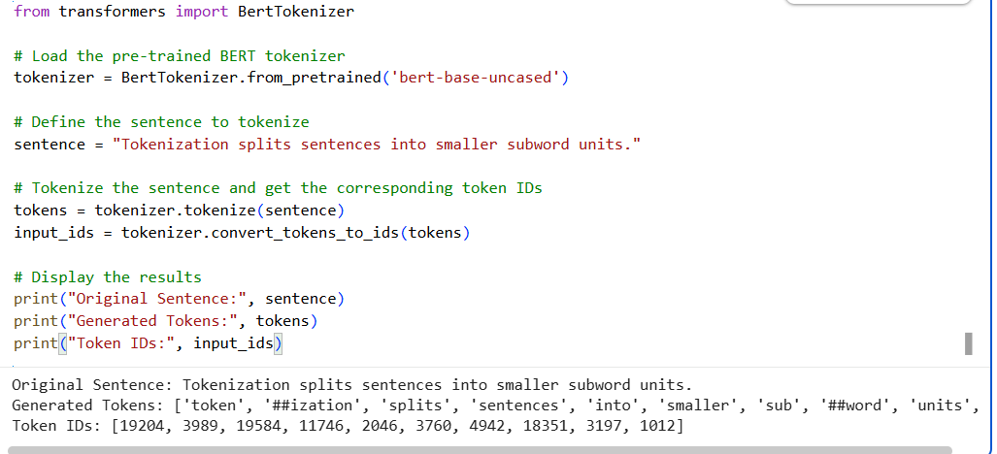

16. Compare the tokenization outputs of BERT and GPT-2.
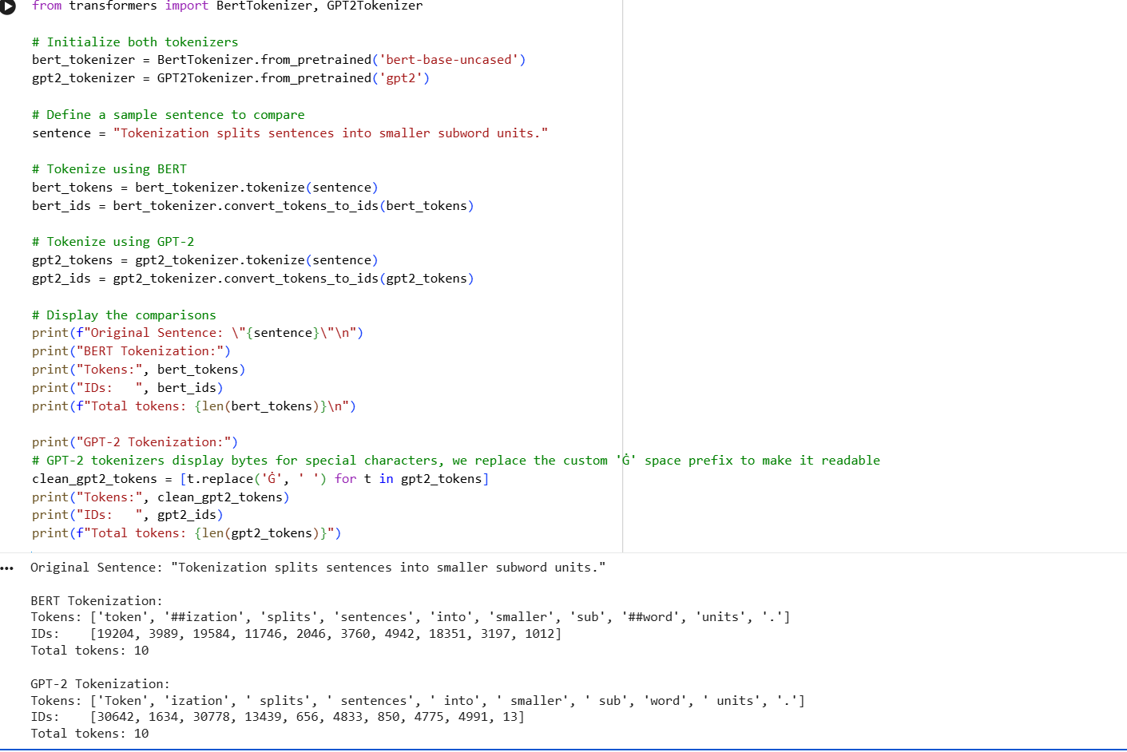
17. Generate contextual embeddings for a sentence using BERT.

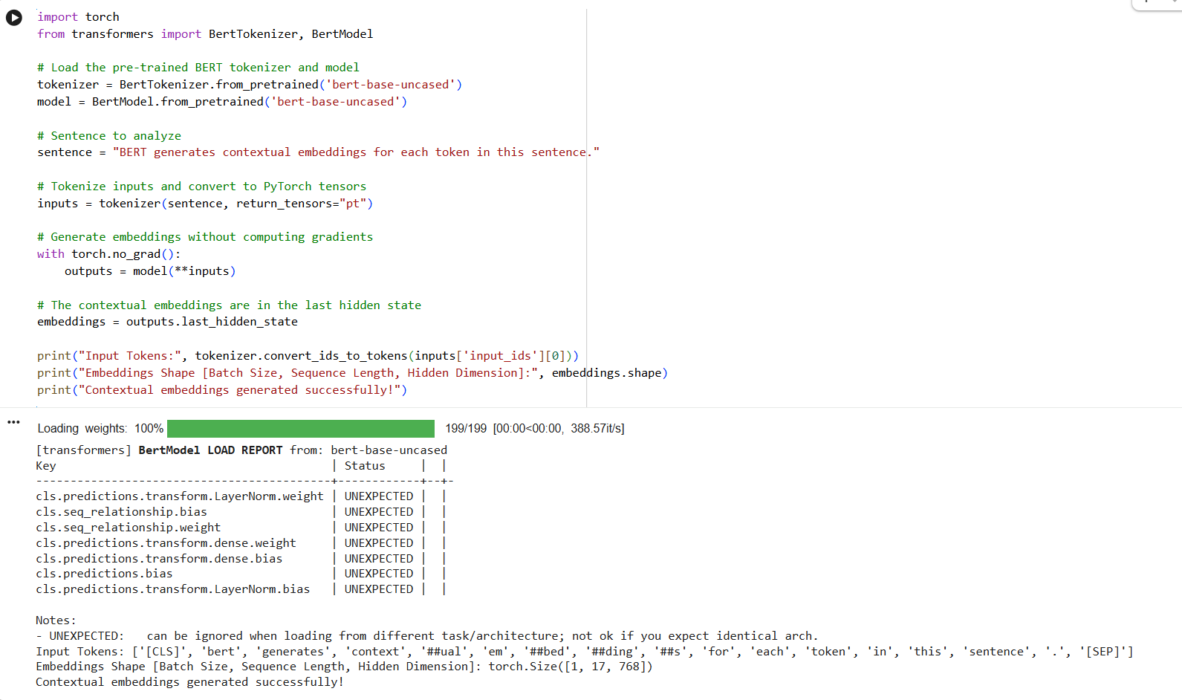
18. Compare contextual embeddings generated for two semantically similar sentences.
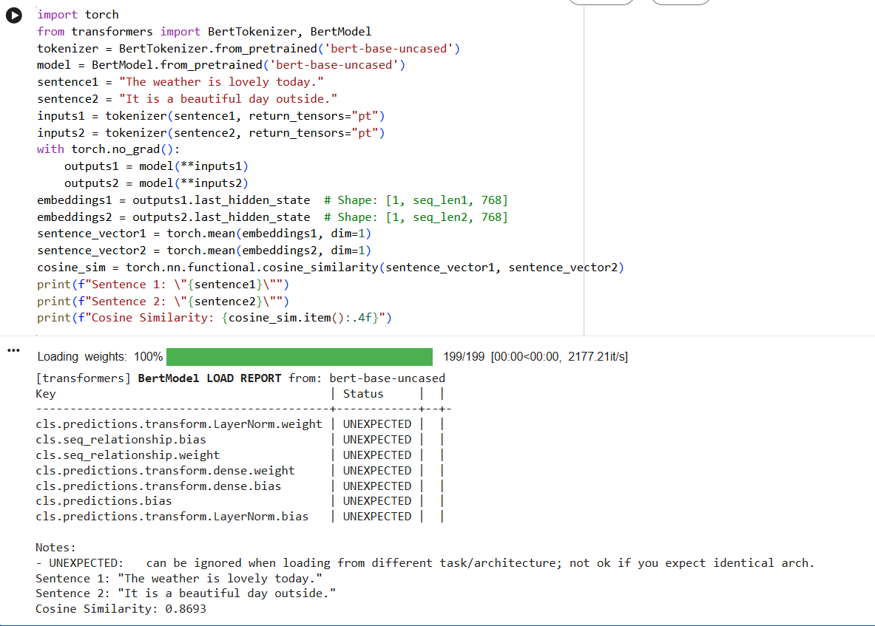

19. Generate text from a prompt using the GPT-2 language model.
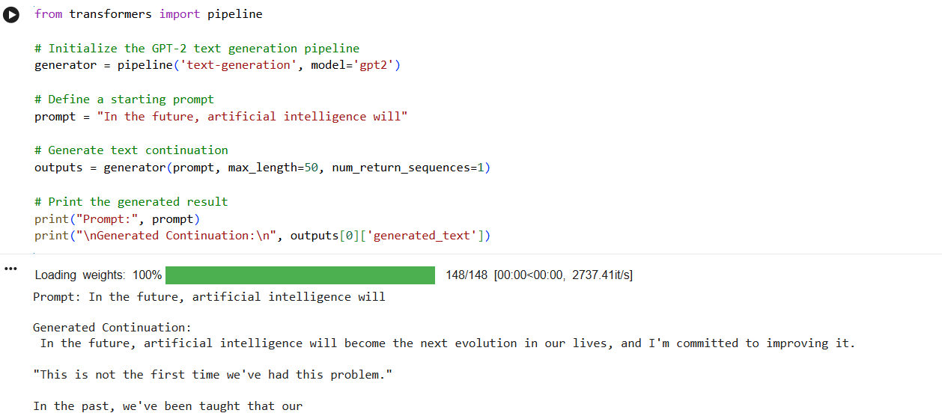

20. Generate and compare responses for multiple prompts using a pre-trained LLM.
